Project Design Phase
Solution Architecture

Date | 5 February 2025
Team ID | LTVIP2026TMIDS82001
Project Name | electric motor temperature prediction using machine learning
Maximum Marks | 4 Marks

Solution Architecture:
Solution architecture is a structured process that bridges the gap between industrial motor overheating problems and a machine learning based predictive solution. Its goals are to:
● Find the best technical solution to predict motor temperature and prevent overheating failures.
● Describe the structure, components, data flow, and behavior of the motor temperature prediction system to project stakeholders.
● Define features such as data collection, preprocessing, model training, prediction interface, and performance evaluation.
● Provide specifications according to which the machine learning solution is developed, tested, deployed, and maintained.

Example - Solution Architecture Diagram:
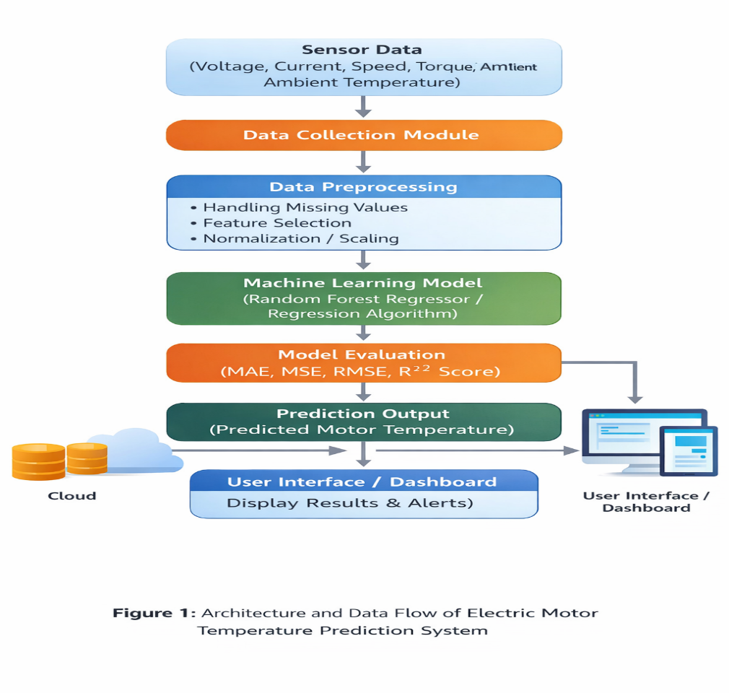

Figure 1: Architecture and Data Flow of Electric Motor Temperature Prediction System
Reference: https://aws.amazon.com/blogs/industries/voice-applications-in-clinical-research-powered-by-ai-on-aws-part-1-architecture-and-design-considerations/

